# MiniZinc Report

A solver may waste a lot of effort on gazillions of (partial) non-solutions that are symmetric to already visited ones, whereas a found solution can be transformed without search into a symmetric solution in polynomial time.

Then, when the symmetry of a problem is found, the efficiency of solving the problem can be greatly improved. In this question, there are two main symmetries.

1. Model symmetries: all resources of the same type

Assuming that a drone needs to land, selecting land Pad1 or land Pad2 has no effect on the selection of the final shipping order, that is, selecting land Pad1 or land Pad2 has no difference. Suppose there are N land pads, then land pads can be permuted: N! variable symmetries, and all these permutations preserve solutions.

In the question, there are two cases: first, the numbers of the same kind of resources used by drones using the same kind of resources and the same time period are symmetrical. Second, when resources are abundant, drones can choose any number of a resource.

Therefore, this static symmetry breaking allows us to eliminate symmetric solutions through constraints. The following constraints simplify the resource allocation of drones: for drones with the same start time, each value in the resource is less than the next one.

constraint forall (d1,d2 in DRONE，a in {LAND,INSPECT,FULLSERVICE,RECHARGE,PACK} where(d1<d2)/\

(start[d1,enum_next(ACTION,a)]=start[d2,enum_next(ACTION,a)])/\(start[d1,a]=start[d2,a]))(

resource[d1,a]< resource[d2,a]);

Another way is to stipulate that when there is no competition for resources, the drone with small number will give priority to the resources with small number.

1. Instance symmetries : drones in the same state

Drones in the same state can also be instance symmetries which are detectable in the instance data of this problem.

Suppose there are two drones, drone1 and drone2, and the orders to be dispatched are x1 and x2 under the same arrival time and power. Then consider the following two situations:

Drone1 dispatch x1, drone2 dispatch x2

Drone1 dispatch x2, drone2 dispatch x1

The results of these two cases are the same, that is to say, the drone in the same state is symmetrical.

Therefore, this static symmetry breaking allows us to eliminate symmetric solutions through constraints. Lexicographic ordering constraints along one dimension of an array break the index symmetry of that dimension.

constraint forall(d1,d2 in DRONE where(d1<d2)/\

(arrival[d1]!=arrival[d2])/\

(charge[d1]!=charge[d2])/\

(order[d1]!=0)/\order[d2]!=0)

(lex_lesseq([order[d1]],[order[d2]]));

Or we can specify that the drone with smaller number send the order with smaller number:

constraint forall(d1,d2 in DRONE where(d1<d2)/\

(arrival[d1]!=arrival[d2])/\(charge[d1]!=charge[d2]/\(order[d1]!=0)/\order[d2]!=0))

(order[d1]<order[d2]);

1. Compare

Running with gecode6.3.0, the results are summarized in the following table

|  |  |  |  |  |  |
| --- | --- | --- | --- | --- | --- |
|  | Symmetry is not excluded | Exclude only symmetry of resources | Only drone symmetry is excluded | The symmetry of resources and drone is excluded at the same time | Reason |
| drone0 | 1s 341msec | 1s 261msec | 1s 545msec | 1s 103msec |  |
| drone1 | 4s 370msec | 6s 249msec | 4s 600msec | 1s 97msec | Resources are never idle |
| drone2 | 2s 156msec | 1s 824msec | 2s 89msec | 1s 924msec | Drone is basically different |
| drone3 | 5m did not get the final result | 5m did not get the final result | 816msec | 666msec | drone quantity equals order quantity |
| drone4 | return Unsatisfied in 496msec | return Unsatisfied in 617msec | return Unsatisfied in 487msec | return Unsatisfied in 504msec | Too few resources |
| drone5 | 599msec | 599msec | 592msec | 594msec | The drone status is different, and the resources are abundant |
| drone6 | return Unsatisfied in 459msec | return Unsatisfied in 354msec | return Unsatisfied in 349msec | return Unsatisfied in 350msec | Too few resources to schedule orders |
| drone7 | return Unsatisfied in 350msec | return Unsatisfied in 349msec | return Unsatisfied in 356msec | return Unsatisfied in 346msec | Not enough packs |
| drone8 | return Unsatisfied in 379msec | return Unsatisfied in 385msec | return Unsatisfied in 384msec | return Unsatisfied in 375msec | Not enough packs |
| drone9 | 5m did not get the final result | 4m 19s | 1m 35s | 1m 10s | The symmetry here is well reflected. Obviously, optimization plays a role |

1. Sensitivity analysis

In this section, I will examine each drone file and consider which constraints have the greatest impact on profits.

|  |  |
| --- | --- |
|  | Stage G: modify the value |
| drone1 | The profit obtained from the original data is 28, which is already the maximum profit. Without considering adding drones, we can consider modifying the pack time to [1,2,1,1] so that the time axis can be shortened. |
| drone2 | The profit obtained from the original data is 44, which is already the maximum profit. Without considering adding drones, we can consider modifying the pack time to [1,2,1,1] so that the time axis can be shortened. |
| drone3 | It is observed that the number of resources is still sufficient, but the drone lacks power and takes a long time to pack. The horizon is changed to 25, and the profit is increased from 54 to 59 |
| drone4 | Increase the number of resources and extend the time resources to [3,1,1,8,10,10]; Horizon is changed to 17; Profits can be withdrawn 59 |
| drone5 | The resources are abundant, and the drone does not need to be recharged. The profit is already the maximum and cannot be improved. Without considering adding drone, we can consider modifying the pack time to [1,2,3,1] so that the time axis can be shortened |
| drone6 | Increase the number of resources = [1,1,1,2,3,3]; Get a profit of 32 |
| drone7 | Set pack resource to 2 and get a profit of 32 |
| drone8 | Set the pack resource to 2 and get a profit of 27, or extend the maximum time to 23 and get a profit of 29 |
| drone9 | Considering the power of the drone, the power of the third, fourth and seventh drones is changed to 10charge = [5,3,10,10,5,3,2,10,10,10], and the profit is increased from 83 to 98 |

In addition, the profits of drone 1, drone 2 and drone 5 cannot be increased. If drone drone1, drone2, and drone5 is added with an arrival time of 0 and a power of 10, the profits can be increased by 3, 5 and 5 respectively.

In summary, we can make the following decisions about the drone data:

Strategy 1: increase the number of resources. This is feasible for some inputs, such as drone3, drone6, drone7 and drone8. Due to the resource problem, the required solution was not obtained at the beginning.

Strategy 2: maintain high power for all drones. For example, drone1 sets the power of drone 3 to 10, so that it does not need to be charged quickly, and the profit will become 28.

Strategy 3: with the idea of strategy 2, the adjustment that can be made is to extend the maximum time limit. After the time is extended, all drone should not be charged quickly, and the cost of fast charging will be reduced.

Strategy 4: similar to the above, the weight of goods can be reduced to avoid charging, which may reduce the cost of fast charging.

Strategy 5: another way to increase the timeline is to reduce the packaging time and increase the timeline in disguise.

Strategy 6: make all orders ready in a very early time, so that all drones can return at the beginning. In this way, the sub problem becomes to select the most expensive order of ndrones.

1. Conclusion

Optimize drones symmetry: when the number of drone is far less than the order number and most of the drones are in the same state, the running speed of the program is significantly improved, and the optimal solution is quickly obtained. The number of drone is close to or equal to the order number and most of the dornes are in different states. The running speed has no impact. Due to an additional restriction, the solution will be slower.

When resources are abundant, the symmetry of resources is optimized, and the running speed of the program is significantly improved. When resources are scarce, solving the symmetry does not improve the efficiency.

1. Summary

We can break the detected symmetry so that we can spend less effort on solving, that is, to avoid multiple symmetric representations of the solution. When solving, ideally we should keep one member per symmetric class, because this may make the problem easier to solve.

1. 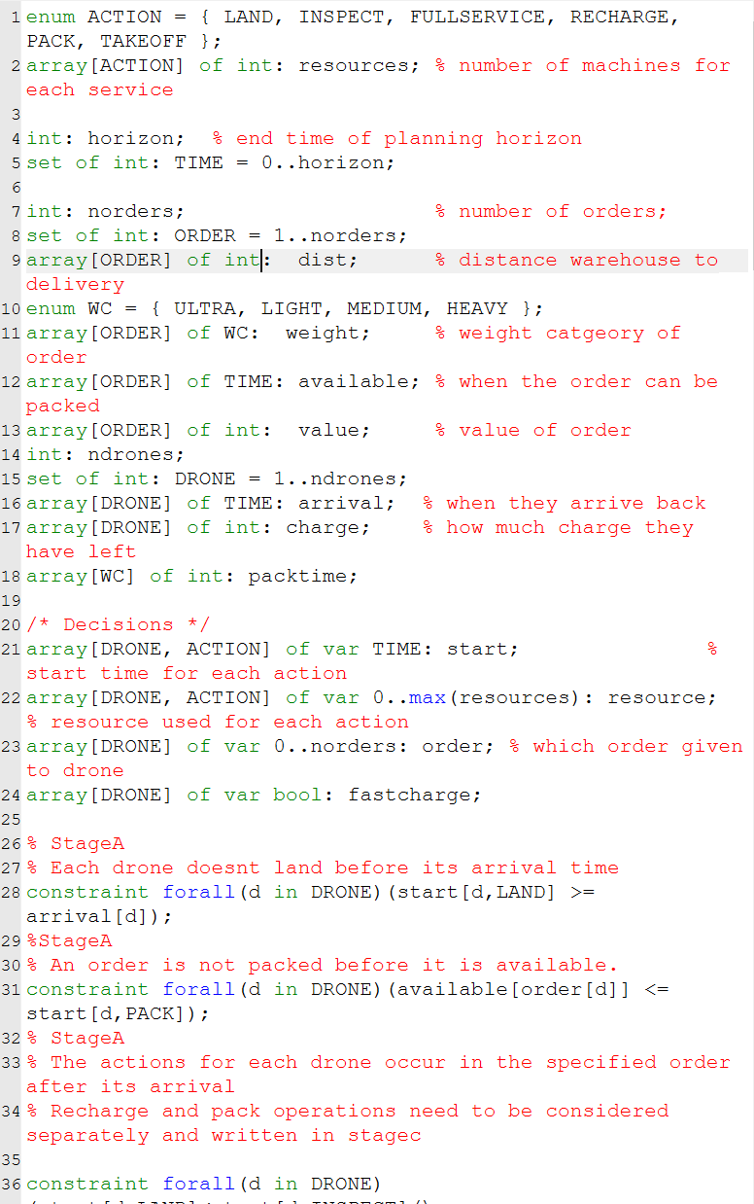Codes

